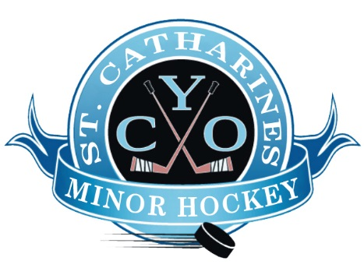
St. Catharines CYO Minor Hockey
5 Park Avenue
St. Catharines, Ontario
L2P 1P9

CYO Minor Hockey
RE: Coaches Vulnerable Sector Check

This letter is to confirm that per CYO Minor Hockey Association’s rules and bylaws, all of our volunteer coaches, trainers, team managers, administrators, and bench staff are required to submit a valid Vulnerable Sector Background Check at the start of the ice hockey season.
Please accept this letter as proof of necessity for the holder to obtain a Vulnerable Sector Background clearance certificate in order to volunteer as a team official with CYO Minor Hockey for players who have registered with our association. The position entails being overseeing practices and being on the ice with the team, as well as being part of the team bench during games. The volunteer does not receive compensation for this position. The volunteer may work with multiple age groups from age 3 to age 17.
Volunteers are aware that they may be contacted to attend and provide fingerprints in the event that records deem necessary.
Full Name of Volunteer:
Date of Birth:
Thank you,
Nicole Chubaty
President, CYO Minor Hockey
president@cyominorhockey.com

